**DAILY ONLINE ACTIVITIES SUMMARY**

|  |  |  |  |  |  |  |  |  |
| --- | --- | --- | --- | --- | --- | --- | --- | --- |
| **Date:** | **18-05-2020** | | | | | **Name:** | **John Alsten Tauro** | |
| **Sem & Sec** | **6th A** | | | | | **USN:** | **4AL17CS037** | |
| **Online Test Summary** | | | | | | | | |
| **Subject** | | **Cryptography network security and cyber laws (CNSC)** | | | | | | |
| **Max. Marks** | | **60** | | **Score** | | | **44** | |
| **Certification Course Summary** | | | | | | | | |
| **Course** | **A Full Stack Web Developer – Beginner to Advanced** | | | | | | | |
| **Certificate Provider** | | | **Udemy** | | **Duration** | | | **19.5hrs** |
| **Coding Challenges** | | | | | | | | |
| 1. **Problem Statement**: 1. Using methods charAt() & length() of String class, write a program to print the frequency of each character in a string. 2. 2. Write down a java program to print even and odd numbers series respectively from two threads: t1 and t2 synchronizing on a shared object Let t1 print message “ping — >” and t2 print message “,—-pong”. 3. Write a c program to Find whether given 2 strings are anagram of another string or not Hint: An Anagram of a string is another string that contains same characters, only the order of characters can be different. For example, "act" and "cat" are anagram of each other. | | | | | | | | |
| **Status: YES, Completed all Programs** | | | | | | | | |
| **Uploaded the report in Github** | | | | | **YES** | | | |
| **If yes Repository name** | | | | | **Alsten_Tauro-4AL17CS037** | | | |
| **Uploaded the report in slack** | | | | | **YES** | | | |

Online Test Details: (Attach the snapshot and briefly write the report for the same)

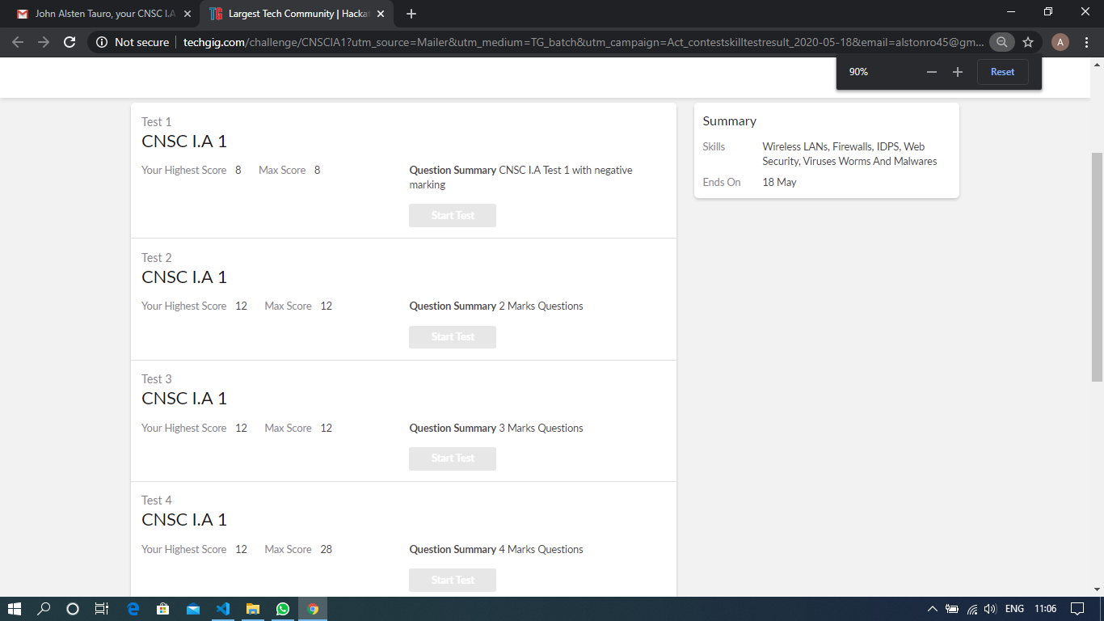

Scored 44 out of 60 in CNSC 1st I.A test

Certification Course Details: (Attach the snapshot and briefly write the report for the same)

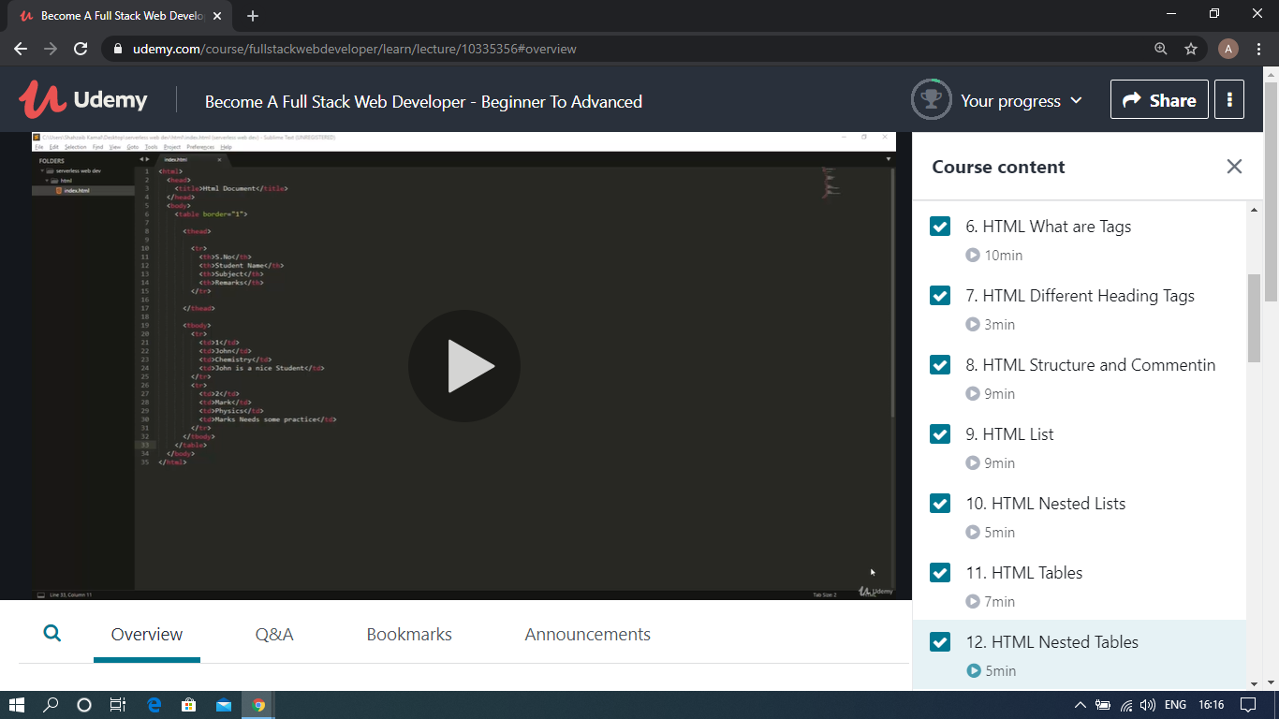

The above course is being taken up by me which is based on the full stack web development. It started with the basics of HTML, Today in Online course I studied about HTML code editor, HTML tags, What is HTML, HTML different heading tags, HTML structure and connection, HTML list, HTML nested list, HTML tables, HTML nested tables. The details of the course and certificate provider is mentioned in the above form.

Coding Challenges Details: (Attach the snapshot and briefly write the report for the same)

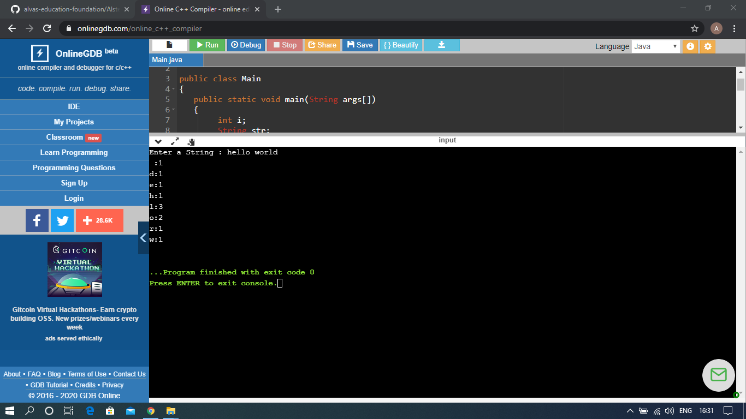

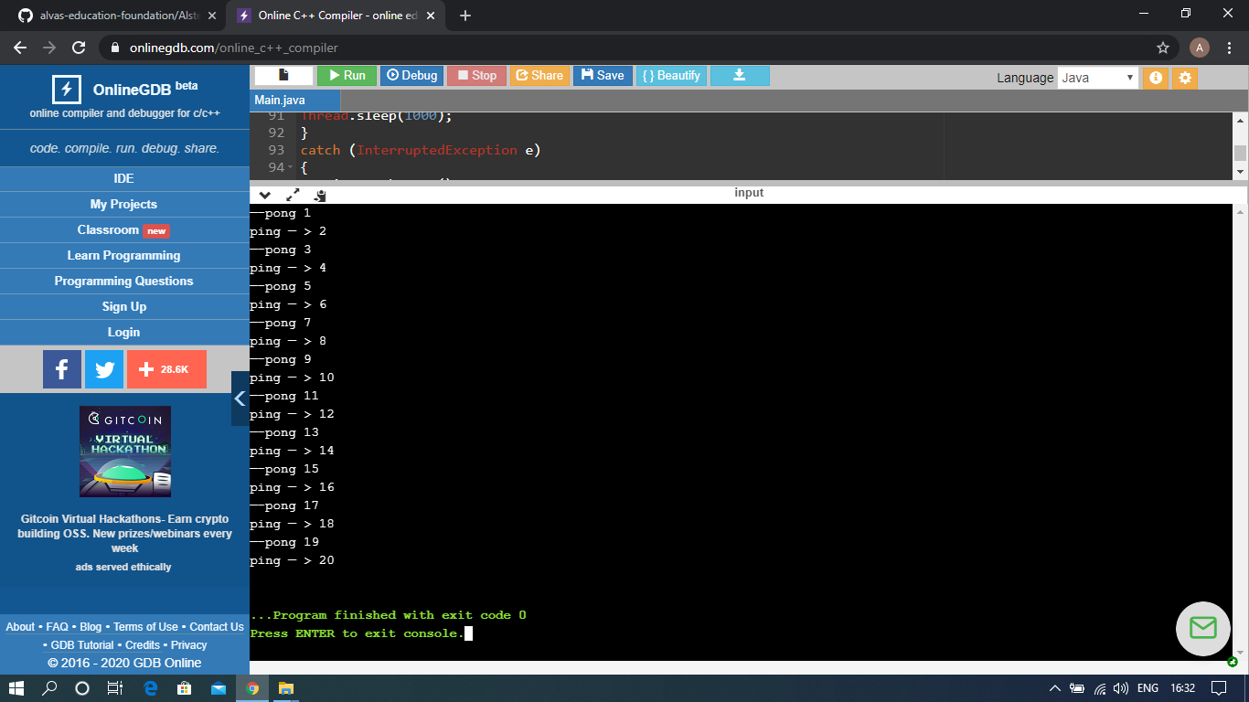

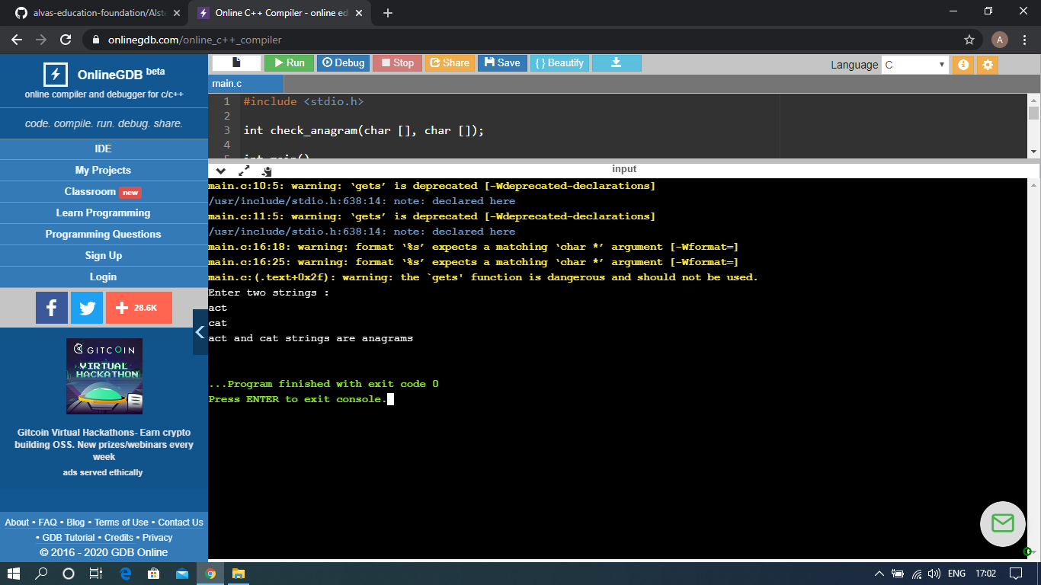

The above Programs were written and executed and the output of the same is displayed above. The code for those 3 programs have been uploaded to the github repository and the link to the same is provided on the form.